**WEEK 7**

**Module 10 – Single Page Application framework – React**

**10. ReactJS-HOL**

**CODE:**

**src/App.js**

import React from 'react';

function App() {

const officeList = [

{

name: 'DBS',

rent: 50000,

address: 'Chennai',

image: process.env.PUBLIC_URL + '/office1.jpeg',

},

{

name: 'WeWork',

rent: 70000,

address: 'Bangalore',

image: process.env.PUBLIC_URL + '/office2.jpeg',

},

];

return (

<div style={{ padding: '30px', fontFamily: 'Arial' }}>

<h1 style={{ textAlign: 'center', color: 'black' }}>

Office Space , at Affordable Range

</h1>

{officeList.map((office, index) => {

const rentStyle = {

color: office.rent < 60000 ? 'red' : 'green',

fontWeight: 'bold'

};

return (

<div key={index} style={{ marginBottom: '40px', textAlign: 'center' }}>

<img

src={office.image}

alt={office.name}

style={{ width: '300px', height: '200px', borderRadius: '5px' }}

/>

<h2 style={{ marginTop: '10px' }}>Name: {office.name}</h2>

<p style={rentStyle}>Rent: Rs. {office.rent}</p>

<p><strong>Address:</strong> {office.address}</p>

</div>

);

})}

</div>

);

}

export default App;

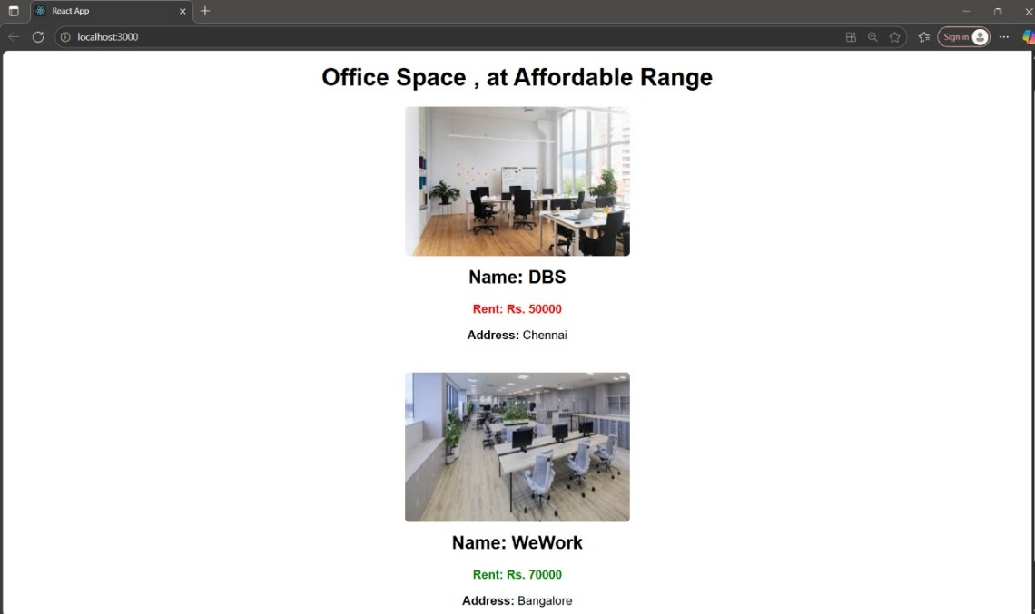**OUTPUT:**